Regression Extensions Assignment
Annabel Mehta
Wages Dataset:
- Plot Wage against Age and evaluate whether a linear or quadratic model would better capture the relationship.
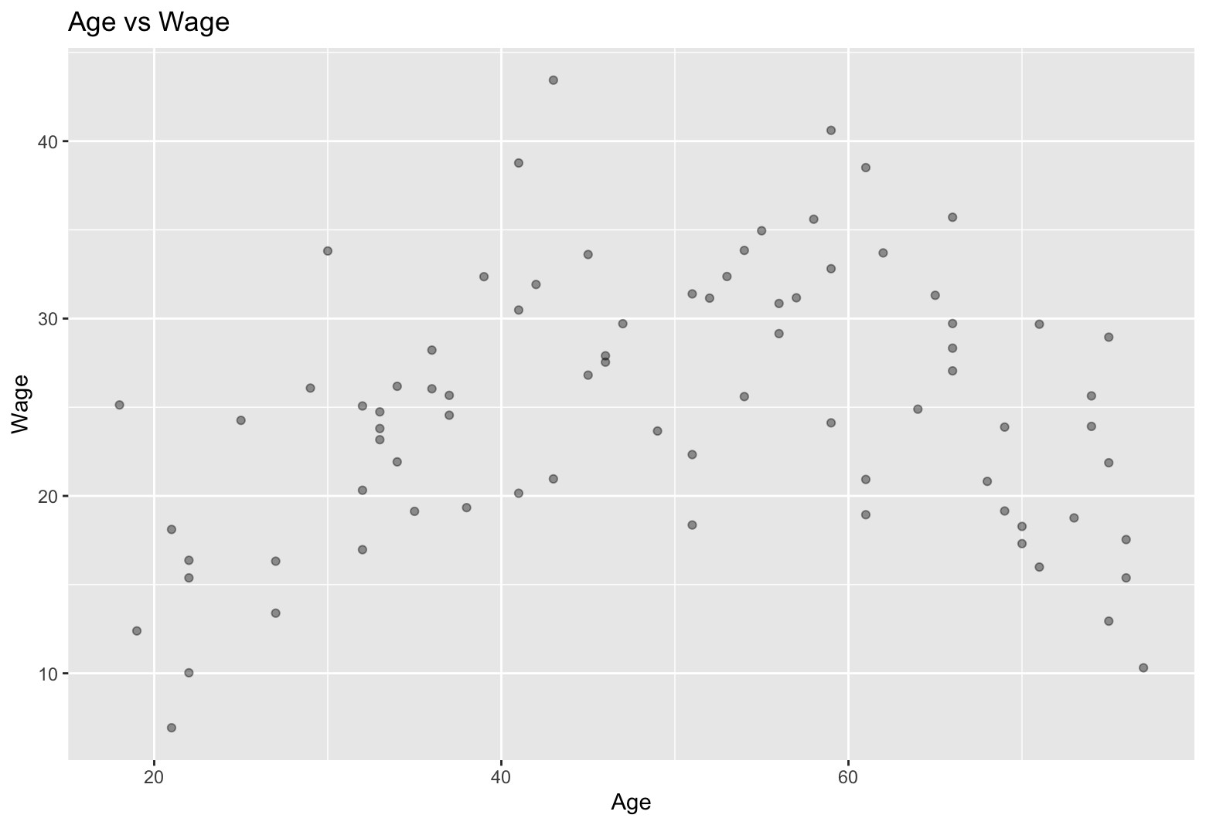
Looking at the Age vs. Wage plot above, a quadratic model would fit best since there seems to be a nonlinear relationship.

- Estimate a multiple regression model of Wage using Age and Education as independent (X) variables; assume a standard linear relationship between Wage and Age.

Wages = 2.63808 + Age(0.04717) + Education(1.44101)

- Estimate another multiple regression model of Wage using Age and Education as independent (X) variables; this time fit Age using a quadratic relationship. Verify your choice from part a. by comparing the distribution of residuals and the goodness of fit between the models in parts b and c.

Wages = -22.721936 + Age(1.350002) + Age^2(-0.013322) + Education(1.253959)
The above model estimates verify that a quadratic model is better a fit for this dataset because the adjusted R-squared value is 0.8257, which is higher than the linear model’s adjusted R-squared value of 0.6088. This means that the quadratic model explains around 82% of the variance within the dataset.

- Use the appropriate model to predict hourly wages for someone with 16 years of education and age equal 30, 50, or 70.

Predicted Wage at 30 = 25.85187
Predicted Wage at 50 = 31.53709
Predicted Wage at 70 = 26.56490

- According to the model, at what age will someone with 16 years of education attain the highest wages?
According to this model someone with 16 years of education will attain the highest wages around 50 years old.

Ann Arbor Dataset:
- Plot Rent against each of the three predictor variables and evaluate whether the relationship is best captured by a line or a curve. Identify variables that may benefit from a log-transformation.
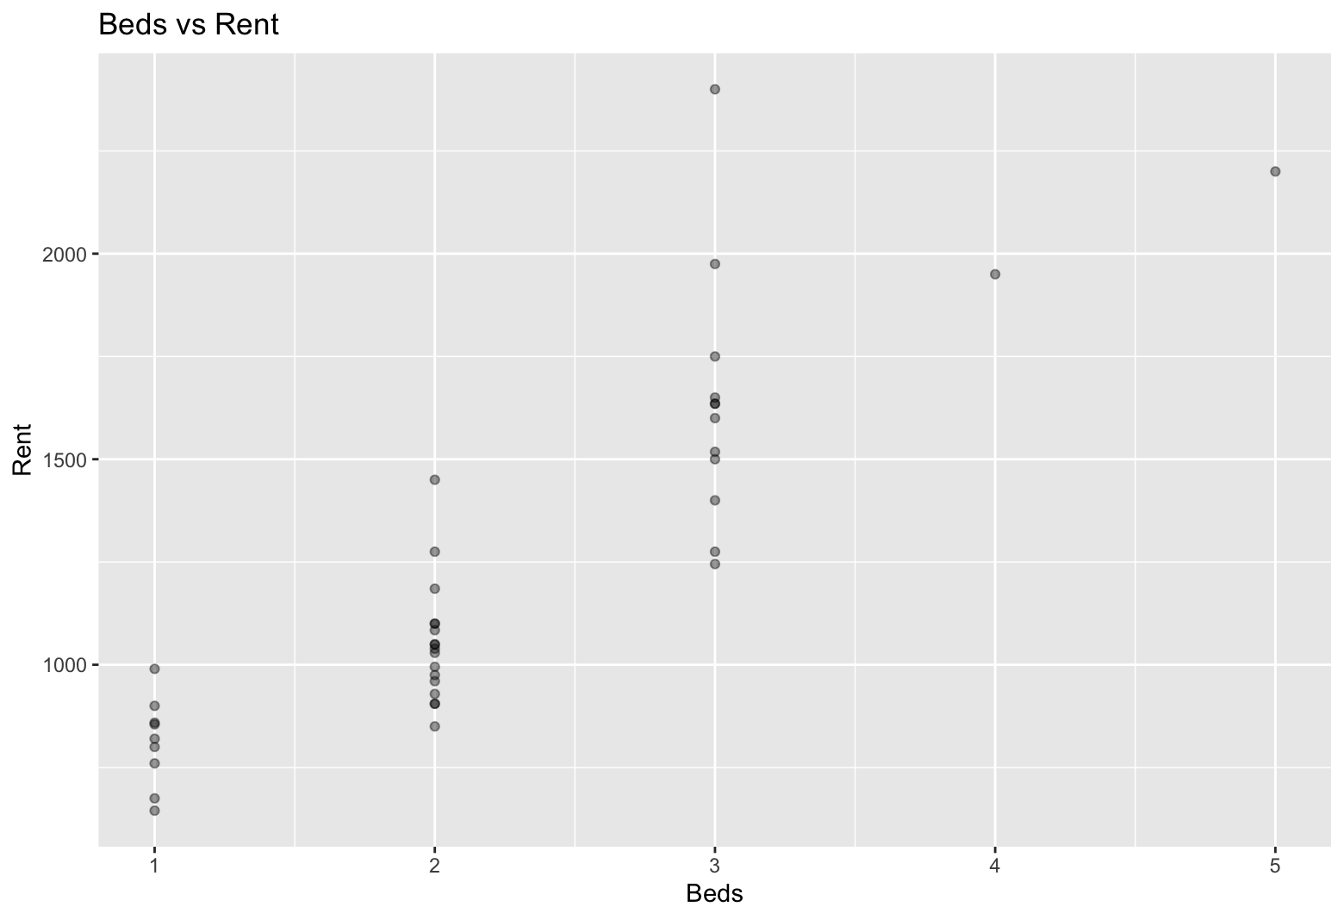
The variable Beds seems to be best captured by a line.
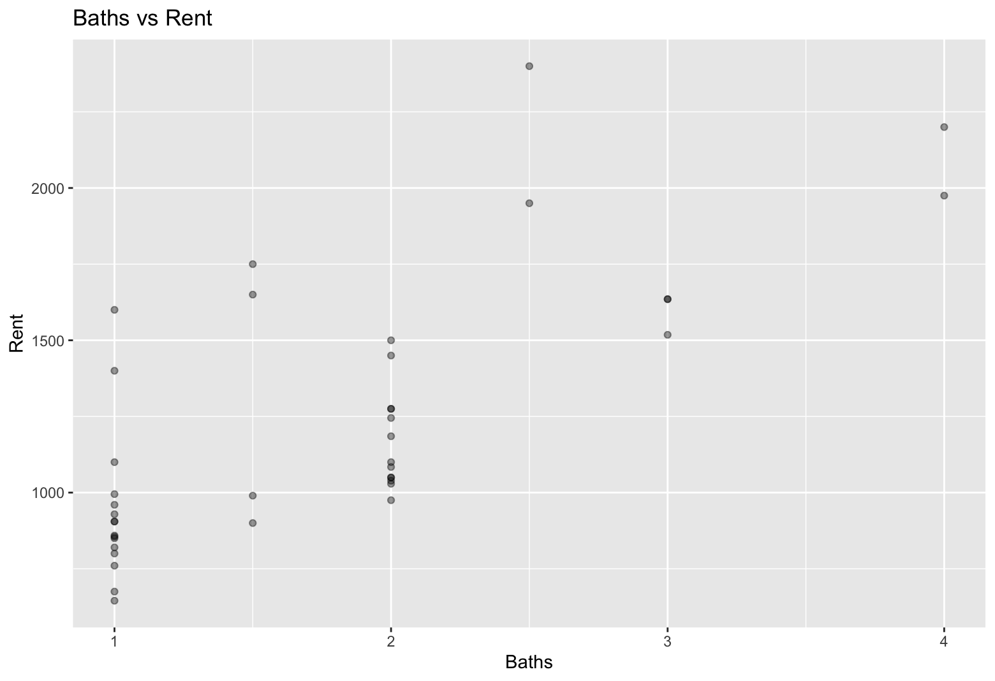
The variable Baths seems to also be captured best by a line.
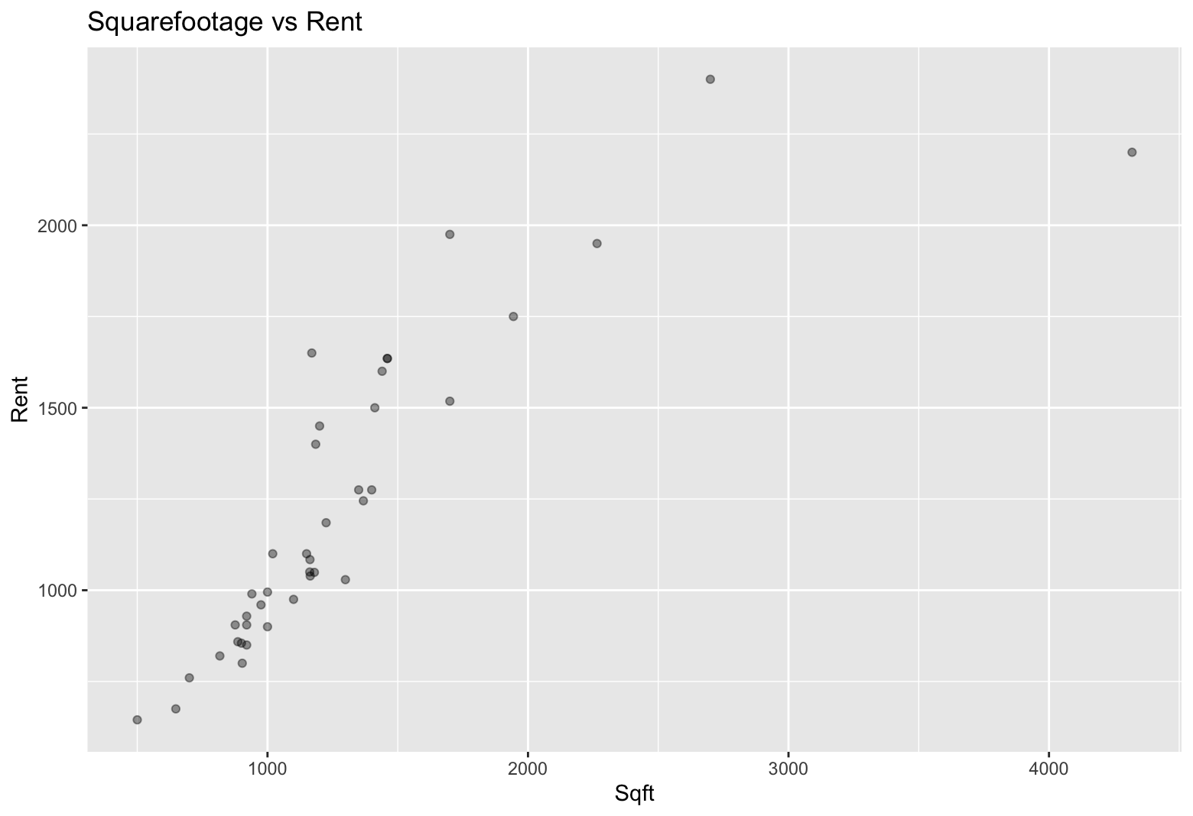
Sqft variable seems to be best fit by a curve since it has seemingly exponential growth.

- Estimate a multiple regression model (with any appropriate log-transformations) to predict rent for a 1,600-square-foot rental with 3 bedrooms and 2 bathrooms.

$1540.384 is the estimated rent.

